Instructions for Using Remote Learning Projects
These materials were developed with the intention of easing the transition between in-class and temporary remote learning. Learning experiences are aligned with curricular outcomes and assessment tools have been included with each project.
Note:
  - The teacher either sends a link to the appropriate project or sends the document itself.
  - The teacher ensures that parents/caregivers receive any required school supplies (bin with pencils, markers, paper, etc.).
  - The teacher reassures parents/caregivers that communication will be maintained between home and school.
  - Parents/caregivers may access additional resources at:
    - My Learning at Home (www.edu.gov.mb.ca/k12/mylearning)
    - My Child in School (www.edu.gov.mb.ca/k12/mychild/index.html)

PROJECT OVERVIEW
Grade: | 8
Main Subject: | English Language Arts and Social Studies
Title: | ARTIFACTS TELL OUR STORIES
Essential Question: | How do artifacts tell our stories and deepen our understandings of ourselves, others, and our relationship to history?
Clusters: | 1, 2, 3, 4, and 5
Duration: | 4–6 weeks
Materials: | Various
Short Description: | This learning experience draws on concepts of artifactual literacy. Students investigate how artifacts tell our stories and deepen our understandings of ourselves, others, and our relationship to history. Students have opportunities to explore multiple forms of texts including visual objects and artifacts that embody lived experiences, values, identities, and cultures. They are introduced to the role of artifacts in history to tell the stories of the past and how multiple perspectives enrich our shared histories. Students are challenged to gather a collection of personal artifacts that represent them, investigate the story of each artifact, and share their findings in an exhibit. This learning experience can be done online synchronously or asynchronously, or a combination of both.

Learning Outcomes
English Language Arts: www.edu.gov.mb.ca/k12/cur/ela/framework/index.html
The four ELA Practices, Elements, and all 6 to 8 Grade Band Descriptors (see Appendix G)
Social Studies: www.edu.gov.mb.ca/k12/cur/socstud/framework/grade8.pdf
Cluster 1: 8-KH-027, 8-KI-008, 8-KH-028, outcomes from Clusters 2, 3, 4, 5 have the possibility of being assessed depending on which historical time period students choose to investigate (see Appendix H)

Assessment
LANGUAGE ARTS |  |  |  |  | MATHEMATICS |  |  | SCIENCE |  |  | SOCIAL STUDIES
COMP.  Listening &  Viewing | COMP.  Reading | COMM.  Speaking & Represent. | COMM.  Writing | Critical Thinking | Knowledge  and  Understanding | Mental Math &  Estimation | Problem Solving | Knowledge  and  Understanding | Scientific Inquiry Process | Design Process &  Problem Solving | Knowledge  and Understanding | Research  and Communication | Critical Thinking and  Citizenship
X | X | X | X | X |  |  |  |  |  |  | X | X | X

Original concept created by: | Linda Connor, Val Noseworthy, Lisa Goolcharan, Angela Burdett

Learning Experiences and Assessment
Question: How do artifacts tell our stories and deepen our understandings of ourselves, others, and our relationship to history?
Summary of the Learning Experience
The detailed learning experience instructions (see Appendix A) and the accompanying PowerPoint can be adapted as needed. Before looking at the PowerPoint and its design overview (see Appendix B), please read this summary to familiarize yourself with the big picture of this learning experience.
What’s the big idea?
In this interdisciplinary learning experience, students engage in purposeful and meaningful experiences that integrate ways of knowing, doing, and being in English language arts and Social Studies. Through inquiry, students will unpack the big idea, the essential question, the four guiding questions, and their own questions generated through research and discussions with others. To maintain the richness of learning through an inquiry stance in this learning experience, students should actively explore their wonderings and investigate them.
The big idea in this learning experience is ‘Artifacts Tell Our Stories.’ As stated in, Artifactual Literacies: Every Object Tells a Story,
“Artifactual literacy is an approach that combines a focus on objects, and the stories attached to them, with an understanding of how different stories have different purchase in particular locations.”
(Pahl & Rowsell, 2011)
This learning experience will provide opportunities for students to enact the four ELA Practices and enable them to explore, represent, and reflect on their own stories related to three main Social Studies GLOs for Grade 8: Identity, Culture, and Community; Citizenship; and Historical Connections.
What is this learning experience?
This learning experience is designed around our essential question, a student challenge, and four guiding questions. Appendix B provides an image of the design of this learning experience that is mirrored on the accompanying PowerPoint.
- The essential question is, “How do artifacts tell our stories and deepen our understandings of ourselves, others, and our relationship to history.” It frames the entire learning experience as an inquiry to be investigated. The question connects to students’ lives, the disciplines of English language arts and Social Studies, and can be applied beyond the classroom. Throughout this learning experience, teachers should refer back to the essential question to situate learning and pull together all four guiding questions.

- The student challenge is to “gather a collection of personal artifacts that represent you to tell each artifact’s story in an exhibit. Using one of the artifacts, investigate any changes through time to evaluate its historical importance/significance.” The student challenge gamifies this learning experience by inviting students into the overarching challenge/quest. The language used to construct the student challenge positions students as decision makers from the very beginning of the learning experience. As students investigate each guiding question, the decisions that students make become more complex and build on each other to strengthen students’ intentional choices in the “final” student challenge. Throughout the learning experience, teachers will guide students in these decision-making processes. Even though, the challenge may seem “final,” students are expected to transfer and apply their learning to other experiences and contexts.
- Four guiding questions are designed to deepen inquiry into “the essential question.” By investigating the guiding questions below, students can more deeply engage with the student challenge:
- What do our artifacts say about us? Why are they important?
- How do we read and interpret stories artifacts tell?
- What are the different stories and perspectives an artifact can tell? How do they enrich our shared histories?
- How do our personal artifacts reflect and deepen our understanding of our shared histories over time?
The investigation of each guiding question includes:
- A learning provocation—critical to investigative, play-based learning to introduce and provoke thoughts, ideas, and actions. A provocation helps to spark curiosity and motivate thinking or investigation.
- A learning sequence organized around first, next, then, and finally—organizes the learning sequence into groups/chunks to help learners manage and understand next steps in the learning experience. It helps to create a supportive learning environment to encourage student risk-taking.
- Learning supports- help all students access and deepen learning using a variety of resources, strategies, and practices to promote student thinking, engagement, and self-regulation.
- A ‘What Do You Think?’ Critical Reflection—encourages students to think critically and make real world connections to their own and others’ ideas. This prompt encourages questioning, analyzing, interpreting, and synthesizing thoughts, ideas, opinions to explain student thinking.
- Evidence of Student Learning—identifies rich descriptions of student learning that become part of a larger body of evidence to help students and teachers reflect on and communicate learning. This documentation can take the form of conversations, observations, processes, and/or products of learning.
Students will have opportunities to explore multiple forms of texts including articles, photographs, historical recounts, videos and artifacts (see Appendix C). These multiple forms of texts embody lived experiences, values, identities, and cultures. Students will also research various historical sources to investigate the stories of artifacts through multiple perspectives, and consider how different perspectives enrich our shared histories. This learning experience can be done online synchronously or asynchronously, or a combination of both.

Other Considerations
Throughout the learning experience, teachers will need to model how to use language for various purposes and contexts and provide targeted small group and individual instruction as needed. Students will need opportunities to conference with teachers, give and receive peer feedback, and reflect on their learning. Several learning supports are provided, but more supports may be needed, specifically around language as system depending on your students’ strengths and needs. For example, it may be useful for students to explore an artifact’s plaque/ tablet that are found in museums. Students could explore multiple plaques/tablets to discuss common language features that are used to tell the story/stories of an artifact. If the PowerPoint is used, teachers may want to divide it into four, one slide deck for each guiding question.
To integrate Career Development in this project, this would be a good time for teachers to introduce the careers associated with artifacts i.e. curator, archaeologist, archaeological field technician, preservation specialist, etc. Seeing the connection between ‘classroom’ learning and jobs/professions related to that learning, helps engage students in their learning.
Teachers may also want to include a shared read aloud that complements this learning experience. Students could help the class choose an historical narrative, memoir, etc. that interests them. Using a novel based on a historical context would provide additional opportunities for students to dig into history and compare artifacts and language from the past with those of today.

APPENDIX (Printable Support Materials Including Assessment)

Grade 8: Artifacts Tell Our Stories.pptx
Grade 8: Appendices
Appendix A: Detailed Learning Experience Instructions
Appendix B: PowerPoint Design
Appendix C: Summary of Text Set
Appendix D: Analyzing Artifacts Graphic Organizer
Appendix E: Curator’s Notes
Appendix F: Documentation of Student Learning
Appendix G: ELA Assessment Tool
Appendix H: Social Studies Assessment Tool

Appendix A
Detailed Learning Experience Instructions
for “Artifacts Tell Our Stories”
Let’s begin….
The Essential Question and Student Challenge
How do artifacts tell our stories and deepen our understandings of ourselves, others, and our relationship to history (Slide 3)
- The teacher will help students familiarize themselves with the overarching essential question, student challenge, and guiding questions of this learning experience. If the teacher chooses to use the accompanying PowerPoint, slides 2 to 4 may be helpful in introducing the learning experience. Throughout this class discussion, the teacher can record ideas and questions and use this information as an anchor chart to refer to throughout the learning experience. To help students unpack their thinking about the essential and guiding questions and student challenge, the teacher can invite students to create a class definition of ‘artifacts’ and “shared histories.”
Guiding Question 1
What do our artifacts say about us? Why are they important? (Slide 5)
SUMMARY: Through the investigation of Guiding Question 1, students explore the meaning of artifacts and explore artifactual literacy, specifically, how artifacts help us understand people’s lives and the societies in which they live. Students investigate many present and past artifacts: teacher artifacts, their own artifacts, and those from people who lived in the past. The teacher uses a set of artifacts to model how to look for clues to determine who the artifacts may have belongs to. Then, using these same artifacts, students continue to look for clues until they have enough information to draw conclusions about whom the artifacts belong. Next, in small groups or pairs, students choose a time in history, a place in the world, and a person in that time period to construct ‘an identity.’ Students find three images of artifacts that could have belonged to that person. Then, the teacher gathers and compiles these sets of images, so students can investigate each set to determine the identity of the person from the past. Through this process, students deepen their understanding of artifacts and the lives of those in the past. Taking on the role of curator, students may be able to identify an additional artifact that would complement each set.
- The learning provocation is for the teacher to share one or more personal artifacts and ask students what they learned about the teacher through these artifacts. Then, students can think about a personal artifacts that matters to them. Then, students share and explain what the artifact is, why it is important to them, and how it helps to tell their story. This is a brief experience to see what students know about artifacts and the ways they can explain the artifact’s story and connect it to themselves and/or other events.
- First, the teacher and students will investigate the collection of artifacts on Slide 9 of the PowerPoint. The teacher will demonstrate how to enlarge the photos and provide an example of one of the pieces of evidence and what it tells us about that particular person. For example, if you look closely at the money it says “Berlin,” so this person lived in Germany.
- Students will closely examine the collection of artifacts to uncover who the artifacts might belong to. Students may need access to the internet to investigate the artifacts.
- Students may choose to write or record their findings about what they know about the person, what kinds of information they learned e.g., where they lived, time in history, etc., and what other artifacts could also be included in this set.

- Next, students will curate a collection of artifacts that represents a person in history.
- Individually or in groups, ask students to choose at time in history, a place in the world, and a job/role in society. They may also include age, gender, etc.
- Students should find at least two or more images of artifacts related to their chosen person and place the images on one PowerPoint slide. They will not reveal who their person is on the slide.
- Students will email their slides, so the teacher can compile them for the next part of this learning experience.
- Then, students will analyze collections of artifacts to uncover the person’s identity.
- Individually or in groups, students use the Analyzing Artifacts Graphic Organizer (see Appendix C) to record observations. Using what students observe in each collection, ask students to consider what other artifacts they might add to these collections. Students will do their best to complete the entire graphic organizer, and can inquire with the group which created each set of artifacts to find out the identity.
- Finally, in the ‘What Do You Think?’ Critical Reflection,” the teacher may choose to have a class discussion about the following prompts or use these for student journaling during asynchronous time. Students will choose a position about the following statements: agree, disagree, or partially agree.
- An artifact provides very little information about the person that used it.
- An artifact only provides evidence of one person’s identity.
- Some documentation of student learning that could be collected for assessment may include:
- The findings from the collection of artifacts (Slide 9)
- PowerPoint slide of artifacts belonging to a particular person in history (Slide 10)
- The ‘Analyzing Artifacts’ graphic organizer (Slide 12)
- Your ideas from ‘What Do You Think?’ (Slide 13)
Guiding Question 2
How do we read and interpret the stories that artifacts tell? (Slide 15)
SUMMARY: Through the investigation of Guiding Question 2, students explore how to read and interpret an artifact and discuss how an artifact changes through time. The teacher begins the investigation by asking students to predict the story of “the suitcase,” an artifact from the Manitoba Museum. Then, in groups, students jot down the physical characteristics of the suitcase and organize them into categories. Looking at their evidence, students discuss how the suitcase is different from suitcases of today. Students dig deeper by researching the physical characteristics of the suitcase and interpreting the suitcase to tell its story. The students share their stories of the suitcase and the teacher shares the curator’s notes of the suitcase.
- The learning provocation is to make a prediction of what the story of the suitcase might be.
- First, students “read the artifact” and record observations, and compare the artifact through time.
- Ask students to observe the images of the suitcase and/or watch the video at https://tinyurl.com/suitcasestory.
- Students will write all the physical characteristics of the suitcase on sticky notes (Only one characteristic per sticky note). You may want to use Jamboard or place sticky notes on a virtual whiteboard. Encourage students to look closely at the suitcase. Use prompts to help them notice shape, color, texture, material, size, weight, age, condition, movable parts, or anything written on the suitcase. Ask students to self-check their sticky notes by asking them if they could describe the suitcase to someone who hasn’t seen it using the physical characteristics they have identified.
- Students sort the physical characteristics of the suitcase into themes/patterns/categories. This helps students make connections between the different kinds of information.
- After, students complete the sort, students will consider what story/stories are emerging. The teacher may want to provide prompts such as “Is there a story or stories emerging from what you observe? What kind of stories are emerging? Who or what are the stories about? Are the stories linked? What are you wondering? What is a similar item from today?”

- Using the sort, students will compare the suitcase to a suitcase today. Discuss the changes through time to understand the significance of artifacts such as the suitcase. Consider social/cultural, political/historical, economical, technological/environmental changes (e.g. new technologies such as GPS trackers). Discuss why some artifacts stay the same and why some change over time?
- Next, students will research and interpret the artifact. They will share their thinking about the artifact.
- Students will analyze and add to the information in the sort by researching different aspects of the suitcase. They may choose to research online by using different keywords or reach out to individuals with specific questions about the suitcase.
- Students will interpret all the information they have gathered about the artifact. What does it tell them about the time, place, and people? Students may find the questions on “Try to Make Sense of It” useful at www.archives.gov/education/lessons/worksheets/artifact.html.
- Students will share their sort and their thinking. What are their findings so far? What story/ stories are emerging about the artifact? Students may choose to videotape the sort while explaining their thinking or take a picture of the sort with a written explanation.
- Then, students will individually or in groups tell their story of the suitcase. They will use the evidence they gathered in the sorting activity to discuss their interpretation. On Slide 24, there is a set of questions to help students with this process. Students will share their stories and the teacher will share what is known about the suitcase from the MB Museum (see Appendix E). If time permits, students can record their story and post it on Flipgrid.
- Finally, in the ‘What Do You Think?’ Critical Reflection (Slide 25), the teacher may choose to have a class discussion about the following prompts or use these for student journaling during asynchronous time. Students will choose a position about the following statements: agree, disagree, or partially agree.
- It is easy to uncover the story or stories of an artifact.
- All artifacts change, but some change through time more quickly.
- Some documentation of student learning that could be collected for assessment may include:
- Key points in discussion about the suitcase through time (Slide 20)
- Sorting activity with an explanation (Slide 22)
- The telling of the suitcase’s story (Slide 23)
- Your ideas from ‘What Do You Think?’ (Slide 25)
Guiding Question 3
What are the different stories and perspectives an artifact can tell? How do they enrich our shared histories? (Slide 27)
SUMMARY: Through the investigation of Guiding Question 3, students explore how exhibits are created collaboratively, the importance of multiple perspectives in understanding our shared histories, and the important role of museums and historic sites. The teacher and students watch a video and discuss the different perspectives historians, curators, artists, and archeologists bring to an exhibit. In pairs, students choose an artifact from history that interests them and that showcases one or more aspects of society. Using the curator’s notes from the suitcase, the teacher models how to identify the perspectives: social/cultural, political/historical/, economical, and technological/environmental. Students continue this process of identifying the different perspectives using the colour coding modelled by the teacher. Next, each pair of students tell the multiple perspective story of their chosen artifact by closely examining and researching its history. They make design choices as they create their exhibit together and choose how to present it to their classmates.
- The learning provocation is to view Preserving Métis Material Culture: Behind the Scenes at Parks Canada. www.youtube.com/watch?v=iQoMgqNx8yI.
- As students view have them think about and then discuss the following questions: When historians, curators, artists, and archeologists work together, what are they hoping to achieve with an exhibit? How does each role bring a unique perspective to the exhibit?

- First, individually or in pairs, students will collect an artifact or image of an artifact from past or present, near or far that interests them to share. The chosen artifacts should show different aspects of society (e.g., culture, education, science, trade, power, war, sports).
- Students may want to explore “A History of the World in 100 Objects” as a starting point. www.bbc.co.uk/ahistoryoftheworld/about/british-museum-objects.
- Ask students to present the artifacts to a partner or group to share what they know about the artifact. The 5 Ws and an H may help students share what they know.
- Next, students will analyze the multiple perspectives of the suitcase and their chosen artifact to understand how multiple perspectives of an artifact enrich our shared histories.
- Teacher and students will read the curator’s notes/background of the suitcase to analyze multiple perspectives; for example, social/cultural; political/historical; environmental/technological; and economical. Students can colour code the different perspectives using the example in Appendix E. The class may decide that a piece of information lends itself to more than one perspective.
- Students will dig deeper into their artifact by analyzing its significance and researching different perspectives (for example, social/cultural; political/historical; environmental/technological; and economical).
- After gathering information, students can revise their drafts by checking for accuracy and ensuring they include multiple perspectives using a similar technique as the Curator’s Notes. The teacher should consider allowing time for peer revision conferencing. Slide 33 provides students with steps to help them revise the artifact’s story.
- Then, students will create and share a mini exhibit of their artifact that showcases the artifact’s story through many perspectives.
- Student can create their exhibits using materials from home or create it digitally in a program such as PowerPoint. The exhibit will feature the artifact with a plaque. The plaque should include the artifact’s name, date, and story. The story should include multiple perspectives and may include other photos and artifacts that bring their artifact’s story to life.
- Students can share their exhibits in a variety of ways such as synchronously with students showing their artifact and explaining its multiple perspectives or this process could be recorded in Flipgrid to share or complied in a class PowerPoint etc.
- After viewing/experiencing all the mini exhibits, students discuss why it is so important to look at an artifact from different perspectives. How does this enrich our shared histories?
- Finally, in the ‘What Do You Think?’ Critical Reflection (Slide 36), the teacher may choose to have a class discussion about the following prompts or use these for student journaling during asynchronous time. Students will choose a position about the following statements: Agree, disagree, or partially agree and then explain their thinking.
- It is important to analyze history from multiple perspectives.
- Museums no longer play an important role in our present day lives.
- Some documentation of student learning that could be collected for assessment may include:
- The colour-coded information about the multiple perspectives of the suitcase (Slide 31)
- Research about the multiple perspectives of the student’s chosen artifact (Slide 32)
- Draft of the student’s chosen artifact story highlighting multiple perspectives (Slide 33)
- Mini exhibit of the student’s artifact. (Slide 34)
- Presentation of the student’s exhibit and discussion of all the exhibits (Slide 35)
    - What multiple perspectives do you notice? How do these perspectives enhance the artifact’s story
    - Why is it so important to look at artifacts from different perspectives?
- Your ideas from ‘What Do You Think’ (Slide 36)

Guiding Question 4
How do our personal artifacts reflect and deepen our understanding of our shared histories over time? (Slide 38)
SUMMARY: Through the investigation of Guiding Question 4, students explore their personal artifacts through multiple perspectives and through time, and connect them to shared histories. Students choose three artifacts that represent them. They will use these three artifacts to write multiple perspective stories. They choose one artifact to investigate through time. Students prepare a “Stories of Us” formal exhibit of their artifacts to which family, friends and community members may be invited. Finally, the teacher and students have a class discussion about the essential question and other big ideas that have surfaced during this learning experience and celebration.
- The learning provocation is to view the video, Archaeologists on Remote Canadian Island Make Earth-Shattering Breakthrough about Human History at www.youtube.com/watch?v=Mr3pQcvGOdA and read the article, Found: One of the Oldest North American Settlements at www.smithsonianmag.com/smart-news/one-oldest-north-american-settlements-found-180962750/.
- As students view the video and read the article have them think about and then discuss the following question: How do the artifacts found in British Columbia impact our past and present histories?
- First, students will choose three artifacts that represent them and their history and write an explanation of why they chose each artifact.
- These artifacts should highlight their lived experiences, values, cultures, and overall identity. Students could use things from home or digital representations.
- The artifacts and why students chose each artifact will be featured in their exhibits.
- Next, students will investigate each artifact to tell its story in their exhibit.
- The teacher will introduce the concept of provenance. Provenance is the curator’s term for the history of the artifact since it was made or created.
- Students will investigate the artifact’s provenance. The teacher may need to model research strategies and processes to help students deepen their investigations and understandings of each artifact. Slide 43 provides support to students for this investigation. Students are encouraged to closely examine each artifact, gather information by asking family members and others, and research online. A possible resource is www.literacyideas.com/top-research-strategies-for-students-and-teachers.
- Students can choose to write or record the story of each artifact that highlights its multiple perspective story.
- Students should revise each artifact’s story by checking for accuracy and ensuring they include multiple perspectives. The teacher should allow time for peer revision conferencing. Slide 44 provides students with steps to help them revise each artifact’s story including an open-ended question that helps students think critically about their work.
- Students then choose one artifact from the three to research through history to explain its historical significance.
    - The teacher will provide students with the following questions to help them investigate each artifact: How has your artifact changed through history? How often has it changed and/or stayed the same? Give reasons why these changes may or may not have occurred.
    - Before students begin investigating the artifact, the teacher may want to review processes that occurred during the investigation of the suitcase in Guiding Question 2.
    - Before students dive into researching, the teacher may want to model how to find and interpret research using Clocks through Time at www.localhistories.org/clocks.html.
    - Students will use information from their investigation to write or record a description of the artifact’s historical importance/ significance through history. This information will be featured in their exhibits.

- Then, students prepare to share their exhibit and celebrate their learning.
- Students practice how they will present their exhibit to others. Slide 47 provides students with a checklist to help them prepare their exhibits for opening night of “Stories of Us” Celebratory Exhibits. As they view other exhibits, they should prepare to discuss how artifacts tell our stories and deepen our understanding of ourselves, others, and our relationship to history? Slide 48 helps students prepare for viewing the exhibits and contributing to the discussion about the essential question of this learning experience (how artifacts tell our stories and deepen our understanding of ourselves, others, and our relationship to history). Students will use the questions on slide 50 to help them take notes for the discussions that follow.
- Students will share their exhibits at the “Stories of Us” Celebratory exhibits. The teacher will need to plan this celebration with their students. Some considerations are: What will the itinerary be? How will each presenter be introduced? Who will attend? How will you show your appreciate for one another’s presentations? The teacher and students may invite family members and others in the community to attend this event.
- Finally, after the event ends or in the next class have the big discussion about the following questions:
    - Why are artifacts important? How do artifacts deepen our understanding of ourselves, others, and our relationship to history? How do artifacts impact you?
    - What are some ways you can uncover an artifact’s story/stories? What is the importance of looking at artifacts through multiple perspectives?
    - Do all artifacts change over time? Why or why not? Why might societies stay the same or change over time and how does this impact us?
- Students should document their ideas in writing or in a recording, during or after the big conversation, about the above questions and their learning growth.
- Some documentation of student learning that could be collected for assessment may include:
- Story of each artifact in the student’s collection (Slide 42)
- The research and description of one artifact’s historical importance/ significance throughout history (Slide 45)
- The exhibit and its presentation (Slide 46)
- Conversations and written or oral recordings about the essential question and others in the big conversation (Slide 50)
Grow your Curiosity
Extensions for ‘Our Shared Histories Matter’
- Students can ask their grandparents and others about their artifacts.
- Students can view the video, 12 Most Mysterious Archaeological Artifacts that Really Exist, www.youtube.com/watch?v=imbaot4D1UI.
- Students can visit virtual museums
- The Canadian Museum of History- Search and explore 95 different online exhibits. www.historymuseum.ca/exhibitions/online-exhibitions/
- Smithsonian National Museum of Natural History- Move at your own pace through the 360-degree, room-by-room tour of every exhibit. https://naturalhistory2.si.edu/vt3/NMNH/
- The Louvre, Paris- Take a virtual tour of several famous exhibits, including Egyptian Antiquities. www.louvre.fr/en/visites-en-ligne#tabs
“Visual objects and artifacts are multimodal and sensory texts. We can smell, feel, and hear them. Moreover, artifacts and visual objects embody lived experiences, values, identities, and cultures.”
Kate Pahl and Jennifer Rowsell
References
Pahl, K.H., & Rowsell, J. (2011). “Artifactual critical literacy: A new perspective for literacy education.” Berkeley Review of Education, 2(2), pg. 129–151. https://files.eric.ed.gov/fulltext/EJ1169658.pdf

Appendix B
The Design of “Artifacts Tell Our Stories”
The image below explains the design of the accompanying PowerPoint, Artifacts Tell Our Stories. Teachers may choose to use this image (Slide 2) to help students understand the big picture of this learning experience and the purpose of particular slides. Teachers may want to divide the PowerPoint into four parts, one slidedeck per guiding question, to help students manage information. All slidedecks should include the introductory slides found on Slides 1 to 4.
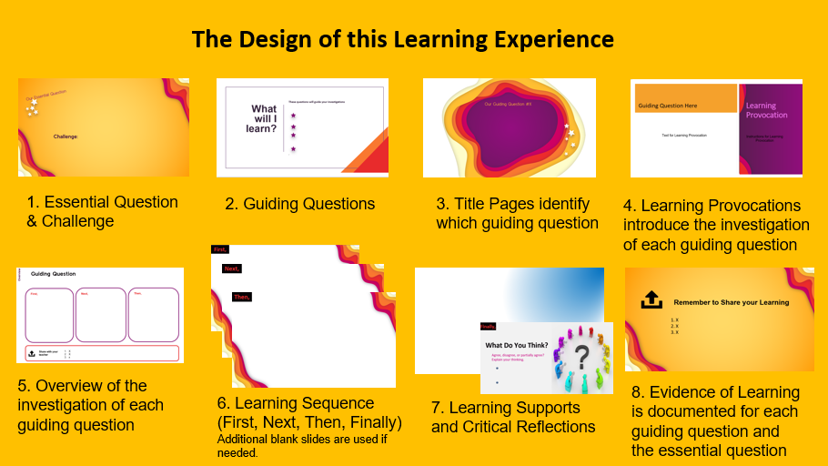
The PowerPoint uses a presentation template by SlidesCarnival with photographs by Unsplash

Appendix C
Summary of Text Set for “Artifacts Tell Our Stories”
Articles
Found: One of the Oldest North American Settlements by Smithsonian Magazine. (2017). The article provides information about the discovery of the 14 000 year old village in British Columbia on Triquet Island, Canada.
www.smithsonianmag.com/smart-news/one-oldest-north-american-settlements-found-180962750/
Artifacts/Photographs
The 100 British Museum Objects by the British Museum. (2010). The artifacts are from the Radio 4 series of A History of the World in 100 Objects. Each artifact includes images and information about what is known about the artifact. www.bbc.co.uk/ahistoryoftheworld/about/british-museum-objects
Tell My Story by Manitoba Education. (2019). Photographs show different views of a suitcase from the mid 1900’s. This artifact is from the Manitoba Museum. https://tinyurl.com/suitcasestory
Untitled image of a horse drawn carriage to fight fires from the 1900s. https://pixabay.com/photos/isolated-fire-1900-2501339/
Untitled image of an imperial banknote from 1909.
https://pixabay.com/photos/bank-note-imperial-banknote-currency-1276958/
Untitled image of a vintage camera from the 1900s.
https://pixabay.com/photos/wooden-camera-field-vintage-retro-2510933/
Historical Recounts
A Brief History of Clocks and Calendars by Tim Lambert. (2020). The recount provides historical information about clocks through time. www.localhistories.org/clocks.html
Curator’s Notes from the Manitoba Museum. The curator’s notes can be found in Appendix E.
Videos
Archaeologists on Remote Canadian Island Make Earth-Shattering Breakthrough about Human History. (2018). The video provides information about a recent archaeological discovery of an ancient settlement on Triquet Island, British Columbia. It highlights the media focus on the artifact’s significance to the scientific community, with little to no discussion about the importance of the artifact to the Heiltsuk Nation. (4:47) www.youtube.com/watch?v=Mr3pQcvGOdA
Preserving Métis Material Culture: Behind the Scenes at Parks Canada. (2016). The video goes behind the scenes of Parks Canada to explore never before seen Métis artifacts. It discusses the collaboration between historians, curators, artists, and archeologists as they created an exhibit. www.youtube.com/watch?v=iQoMgqNx8yI
Tell My Story by Manitoba Education. The video shows a suitcase from the mid 1900s. This artifact is from the Manitoba Museum. https://tinyurl.com/suitcasestory

Appendix D
Analyzing Artifacts Graphic Organizer
Analyzing Artifacts | What do you know about this person?
 | When did  they live? | Where did they live? | Job/Role in Society | Other (age, gender etc.) | What other artifacts might you include?
PPT Slide Number
A.
B.
C.
D.
F.
G.

Appendix E
Curator’s Notes
Suitcase Artifact Background, Manitoba Museum, Winnipeg Gallery—City of Newcomers—Object 6

Multiple Perspectives Legend
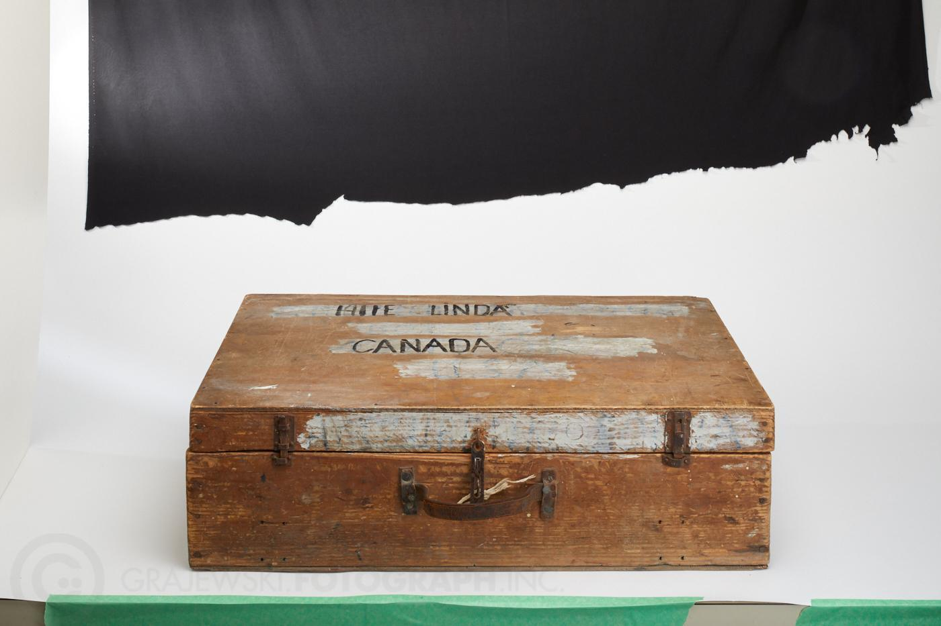
Economical
Political/Historical
Social/Cultural
Environmental/Technological
Figure 1—Suitcase
Suitcase, Mid 1900s, H9-37-392
This simple wooden suitcase with a leather handle was used by Linda Hiie (1922-2001) on her journey from a refugee camp in Germany to Canada in 1951. The suitcase is handmade, possibly from food shipping boxes. It was found decades later in the basement of a home in Winnipeg and was donated to the museum.
Originally from Estonia, Linda’s parents were killed during the Second World War. Linda was homeless and stateless after the Second World War. Categorized as a “Displaced Person,” she lived at a refugee camp in Germany until the Red Cross offered her a work contract in Winnipeg. Linda worked as a bookkeeper at Ogilvie Flour Mills for over thirty years while raising her daughter, Linda Connor.

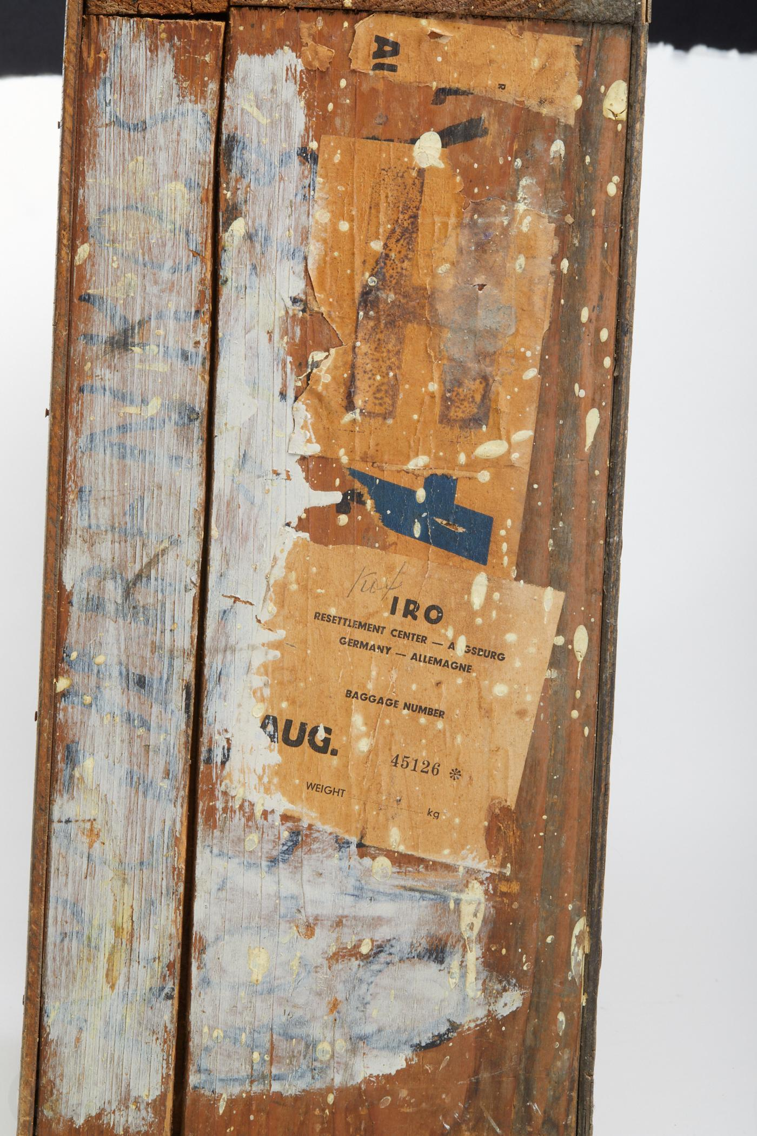
Figure 2—Two stickers on the suitcase show the assistance of the IRO (International Refugee Organization) at the camp in Augsburg, Germany, where Linda Hiie lived for a number of years.
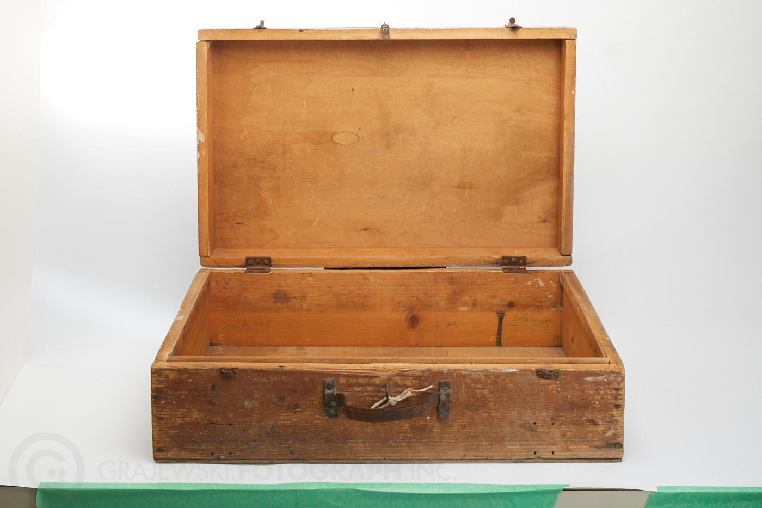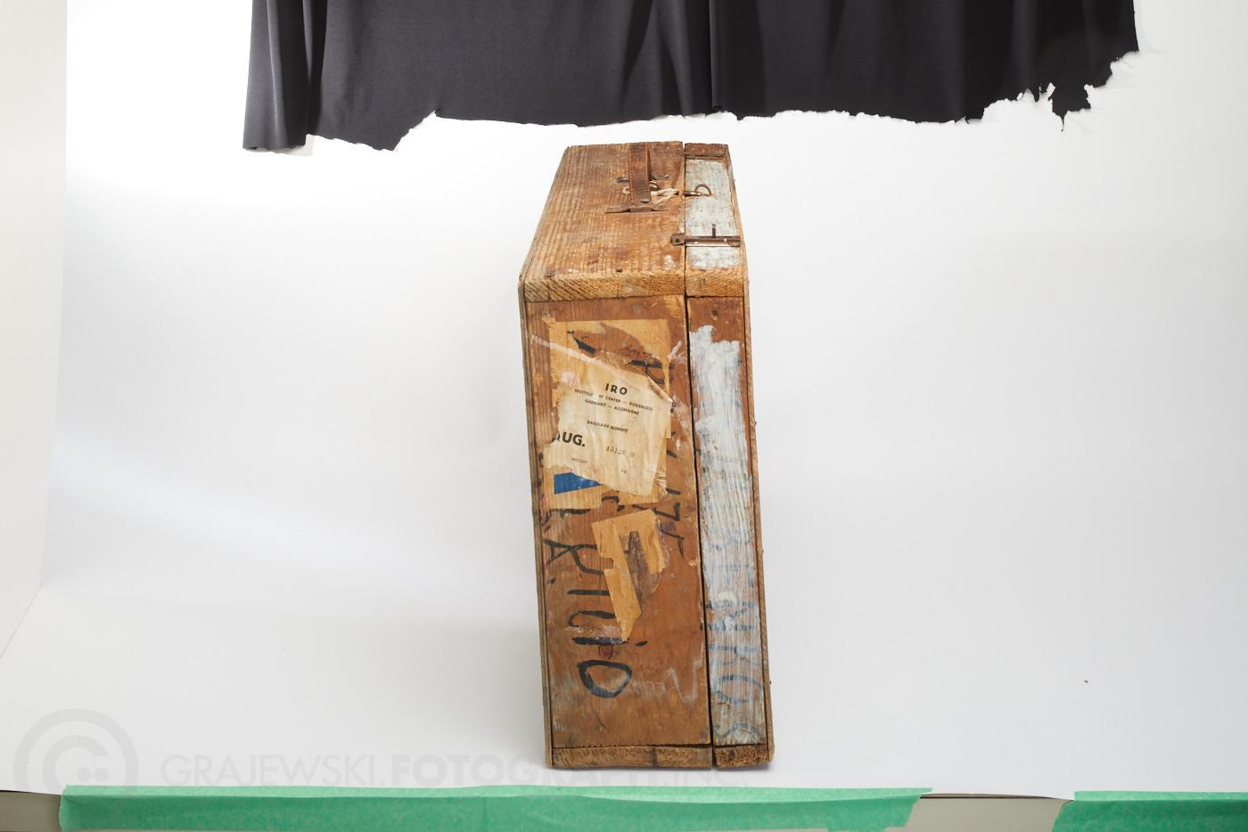
Figure 3—Suitcase open Figure 4—Suitcase full side

Displaced Persons Settle in Winnipeg
In the aftermath of the Second World War, one million Europeans were homeless and stateless. These refugees, or ‘displaced persons,’ needed to be resettled. Canada was cautious about letting displaced persons into the country. Prime Minister William Lyon Mackenzie King worried that there would be a recession in Canada after the war, as there had been after the First World War. He also argued that there would not be enough boats to bring displaced persons to Canada.
Some private agencies worked to bring young displaced persons to Canada and eventually the government changed its policy. In 1947, 5,000 were admitted to the country. In 1948, another 45,000 displaced persons came to Canada. Between 1947 and 1962, 250,000 displaced persons moved to Canada from Poland, Ukraine, Lithuania, the Netherlands, France, and other European countries.
Many Hungarian displaced persons entered Canada under the Sponsored Labour Scheme, where they were expected to work in the lumber, mining, or agricultural sectors for at least one year. Women worked as domestic servants. Many displaced persons made Winnipeg their new home.

Appendix F
(Possible Body of Evidence)
Evidence of Student Learning
Essential Question: How do artifacts tell our stories and deepen our understandings of ourselves, others, and our relationship to history?
Student Challenge: Gather a collection of personal artifacts that represent you to tell your story in an exhibit. Using one of the artifacts, investigate any changes through time to evaluate its historical importance/ significance.
The evidence of student learning below may be gathered through conversations, observations, processes, and/or products.
Guiding Question 1  What do our artifacts say about us? Why are they important? | - The findings about the collection of artifacts (Slide 9)  - The PowerPoint slide of artifacts belonging to a person in history (Slide 10)  - The ‘Analyzing Artifacts Graphic Organizer’ (Slide 12)  - Ideas from ‘What Do You Think’ (Slide 13)
Guiding Question 2  How do we read and interpret the stories artifacts tell? | - Key points from student’s discussion about suitcases through time (Slide 20)  - The sort activity with an explanation of findings and thinking (Slide 22)  - The telling of the suitcase’s story (Slide 23)  - Ideas from ‘What Do You Think’ (Slide 25)
Guiding Question 3  What are the different stories and perspectives an artifact can tell? How do they enrich our shared histories? | - The colour-coded curator’s notes identifying multiple perspectives of the suitcase (Slide 31)  - Research about the multiple perspectives of the student’s chosen artifact (Slide 32)  - The draft of the artifact’s story that highlights multiple perspectives (Slide 33)  - The mini exhibit of an artifact (Slide 34)  - The presentation of the exhibit of one artifact and the discussion of all exhibits (Slide 35)  - Ideas from ‘What Do You Think’ (Slide 36)
Guiding Question 4  How do our personal artifacts reflect and deepen our understanding of our shared histories over time? | - The collection of artifacts representing the student with each artifact’s story (Slide 42)  - The research and description of one artifact’s historical importance/ significance throughout history. (Slide 45)  - The exhibit of the artifacts and presentation (Slide 46)
Enduring Understandings  How do artifacts deepen our understanding of ourselves, others, and our relationship to history? | - Teacher’s anecdotal notes from the conversations during the big conversation.  - Student’s written or oral recordings from before, during, and/or after the big conversation.

Appendix G
ELA Assessment Tool
Grade 8—Artifacts Tell Our Stories
The ELA Assessment Tool is one way you can analyze and record/document what you are noticing in each student’s body of evidence. This analysis can help you identify areas of student learning growth, help with communicating learning, and justify your professional judgements on the Manitoba report card. When you analyze a body of evidence of student learning (see Appendix F) at several points in time, consider:
- Is a student enacting the four ELA Practices, Elements, and 6 to 8 Grade Band Descriptors?
- To what extent? Is there evidence of independence, breadth, depth, and transformation (IDOL-G)?
Evidence of Learning in English Language Arts  https://app.mapleforem.ca/en/groups/229/wiki/pages/1622#6to8overview  *It is important to think about the grade band descriptors in relation to the practice, elements as you look through the body of evidence. |  | Interrelated Dimensions of Learning Growth (IDOL-G) https://app.mapleforem.ca/en/groups/229/wiki/pages/2205 ​
 |  | Independence  Emerging  Expanding  Extending | Breadth  Emerging  Expanding  Extending | Depth  Emerging  Expanding  Extending | Transformation  Emerging  Expanding  Extending
4 ELA Practices & Elements | Grade Band Descriptors Identified
Power and Agency  - Recognize and analyze inequities, viewpoints, and bias in texts and ideas  - Investigate complex moral and ethical issues  - Contemplate the actions that can be taken, consider alternative viewpoints, and contribute other perspectives  Connection to Social Studies Outcomes: S-100, S-302, S-303, S-304, S-306, S-307, S-308, S-310, S-400, S-401, S-402, S-403, S-405 | Learners are recognizing that one’s identities are influenced by various factors and change over time and contexts.
 | Learners are understanding that texts represent and promote particular beliefs, values, and ideas.
 | Learners are exploring multiple perspectives, points of view, and interpretations. Possible Evidence (see Appendix F): 4,8,14, 9,10,11,12,13, 14,15, 18, 19 | e.g. Extending: independently researched and identified different perspectives to tell stories with multiple perspectives | e.g. Expanding: used their own and others perspectives of history to gather and interpret information. Created exhibits for different audiences. Some evidence of using different strategies purposefully | e.g. Expanding: shared opinions and interpretations about the value of artifacts, multiple perspectives, and our shared histories that show deepening understandings of their own and others’ perspectives | e.g. Emerging: opened to learning about new perspectives, but is not yet showing initiative to find new ways to connect multiple perspectives between world views and the cultures of others
 | Learners are exploring their own voices to transform their identities, tell their personal narratives, and critically view their won and others’ views.
 | Learners are collaborating to investigate challenging social issues, moral dilemmas, and possibilities for social justices.

Exploration and Design  - Research and study topics and ideas  - Interpret and integrate information and ideas from multiple texts and sources  - Manage information and ideas  - Invent, take risks, and reflect to create possibilities  Connections to Social Studies Outcomes: S-200, S-201, S-202, S-203, S-300, S-305 | Learners are participating in, extending, and discussing creative processes for designing.
 | Learners are selecting, assessing, and organizing a variety of sources and information for different purposes.
 | Learners are reconstructing, manipulating, and remixing existing texts or sets of text to create new ideas, forms, purposes, and messages.
 | Learners are tapping into and combining experiences with ideas, images, and sounds from various sources to create something new.
Sense Making  - Access, use, build, and refine schema  - Select from and use a variety of strategies  - Be aware of and articulate the ways that one engages with text.  Connection to Social Studies Outcomes: S-106, S-301, S-309 | Learners are monitoring, reflecting on, and discussing processes for making sense of and creating texts.
 | Learners are strategically selecting and applying strategies and processes for making sense of and creating different types of text for different purposes and audiences.
 | Learners are using a variety of thinking processes (e.g. computational, imaginative, creative, interpretive, critical) to make sense of and respond to increasingly varied and complex texts.
 | Learners are using and integrating background knowledge and sources of information purposefully to make sense of increasingly varied and complex.
System  - Recognize, apply, and adapt rules and conventions  - Identify, analyze, and apply understandings of whole-part-whole relationships  Connection to Social Studies Outcomes: S-404 | Learners are more consistently and strategically applying knowledge of and using various resources for spelling, grammar, punctuation, and capitalization.
 | Learners are using their understanding of a ranges of text structures and features to understand and communicate clearly and effectively.
 | Learners are assessing and applying their understanding of how the English language works to understand more challenging and unfamiliar texts, and for clarity, precision, and accuracy in own creations.
 | Learners are examining considering, and using knowledge of conventions of a growing range of forms and genres.

Appendix H
Social Studies Assessment Tool
Grade 8—Artifacts Tell Our Stories
The Social Studies Assessment Tool is one way you can analyze and record/document what you are noticing in each student’s body of evidence. This analysis can help you identify areas of student learning growth, help with communicating learning, and justify your professional judgements on the Manitoba report card. When you analyze a body of evidence of student learning (see Appendix F), consider:
- Is a student demonstrating the knowledge, values and skills of social studies?
- To what extent? Is there evidence of independence, breadth, depth, and transformation (IDOL-G)? https://app.mapleforem.ca/en/groups/229/wiki/pages/2205
Evidence of Learning in Social Studies  https://www.edu.gov.mb.ca/k12/cur/socstud/foundation_gr8/index.html | Interrelated Dimensions of Learning Growth (IDOL-G)  from ELA Curriculum https://app.mapleforem.ca/en/groups/229/wiki/pages/2205 ​
 | Independence  Emerging  Expanding  Extending | Breadth  Emerging  Expanding  Extending | Depth  Emerging  Expanding  Extending | Transformation  Emerging  Expanding  Extending
Specific Learning Outcomes
(Knowledge and Understanding)
8-KH-027 Identify various sources of historical evidence and information and explain how each enhances understanding of the past. Include: archeology, artifacts, literature, art, music, biographies, journals, photographs, oral histories.
8-KH-028 Explain the importance of knowing the past and understanding history.
8-KI-008 Give reasons why societies may stay the same or change over time. Examples: culture, education, trade, power, war...  Possible Evidence (see Appendix F): 5, 8, 14, 16, 17,18,19 | e.g. Extending: Independently analyzed and problem solved how the clocks and chosen artifact changed through time | e.g. Extending: used thinking strategies to research the clock through time and applies these to their chosen artifact | e.g. Emerging:  made some familiar connections to how suitcases have changed through time and showed some initial critical thinking of why societies change using their chosen artifact | e.g. Expanding:  Shared some thoughtful wonderings and reflections that showed new learning about how artifacts and societies have changed over time
*add ‘knowledge and value outcomes’ from
Cluster 2, 3, 4, or 5 based on student choices in the learning experience, specifically choices in Guiding Question 3.

Research and Communication Outcomes
These outcomes are reflected in the ELA Assessment Tool.
S-200 Select information from a variety of oral, visual, material, print, or electronic sources—examples: maps, atlases, art, songs, artifacts, narratives, legends, biographies, historical fiction (exploration and design)
S-201 Organize and record information in variety of formats and reference sources appropriately (exploration and design)
S-202 Interpret primary and secondary information sources for research (exploration and design)
S-203 Select and use appropriate tools and technologies to accomplish tasks (exploration and design)
S-400 Listen to others to understand their perspectives (power and agency)
S-401 Use language that is respectful of human diversity (power and agency)
S-402 Persuasively express differing viewpoints regarding an issue (power and agency)
S-403 Persuasively express differing viewpoints regarding an issue (power and agency)
S-404 Present information and ideas orally, visually, concretely, or electronically. (system)
S-405 Articulate their beliefs and perspectives on issues (power and agency)
Critical Thinking and Citizenship
These outcomes are reflected in the ELA Assessment Tool.
S-100 Collaborate with others to establish and carry out group goals and responsibilities (power and agency)
S-106 Treat places and objects of historical significance with respect—examples: burial grounds, memorials, artifacts (sense making)
S-300 Plan topics, goals, and methods for historical inquiry and research (exploration and design)
S-301 Consider the context of events, accounts, ideas, and interpretations (sense making)
S-302 Draw conclusions based on research and evidence (power and agency)
S-303 Evaluate personal assumptions based on new information and ideas (power and agency)
S-304 Distinguish fact from opinion and interpretation (power and agency)
S-305 Observe and analyze material and visual evidence for research—examples: artifacts, photographs, works of art… (exploration and design)
S-306 Assess the validity of information sources—examples: purpose, context, authenticity, origin, objectivity, evidence, reliability (power and agency)
S-307 Compare differing accounts of historical events (power and agency)
S-308 Compare diverse perspectives in the media and other information sources (power and agency)
S-309 Interpret information and ideas in a variety of media—examples: art, music, historical fiction, drama primary sources (sense making)
S-310 Recognize that interpretations of history are subject to change as new information is uncovered or acknowledged (power and agency)

